**Computer Networks**

**CS314**

**Project User Manual**

**Check-ins Validation**

Prepared By

Osman Ali Mian: k112123 (Section E)

Muhammad Arsalan Badar: k11-2018(Section C)

Contents

Login 3

Check In: 3

Add current location Manually: 4

Check In Error Checking : 5

Login**:**

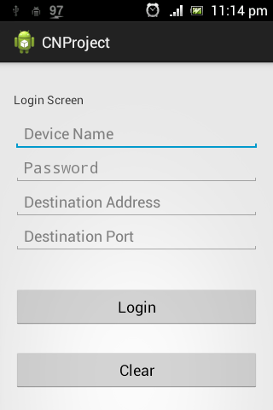

1. Open Application
2. Enter Password of your device.
3. Enter Valid Destination IP (XXX.XXX.XXX.XXX)
4. Enter Valid Port Number (number > 1024)
5. Press Login Button.
6. A pop up message will come indicating status of login.

# Check In:

1. Open your GPS.
2. Open Application.
3. Login into your account.
4. Select Venue for check in from given list.
5. Press “Check In” Button on the screen for check in or press “Back” button to select other Venue.
6. Status Screen will pop up indicating the status of check in.

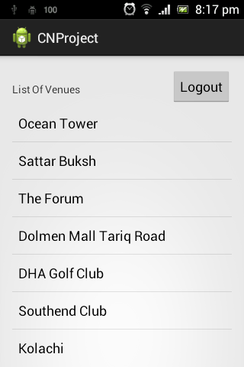

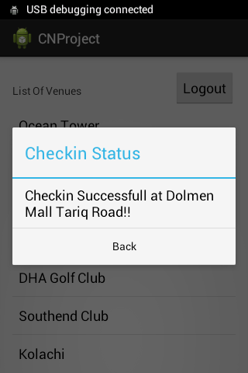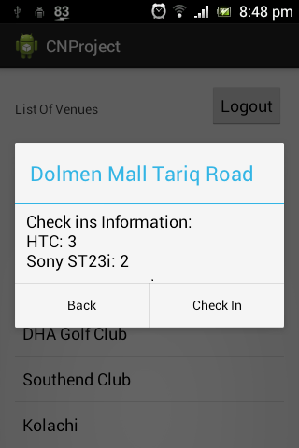

# Add current location Manually:

1. If your GPS is not working, the application will show error.
2. To enter GPS press button “Enter GPS Location”
3. Now enter Valid Latitude and longitude in respective fields.

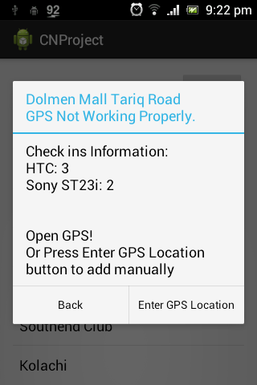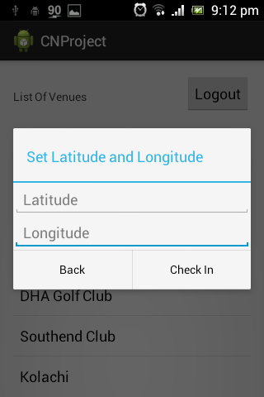

**Application Screenshots(Error Handling):**

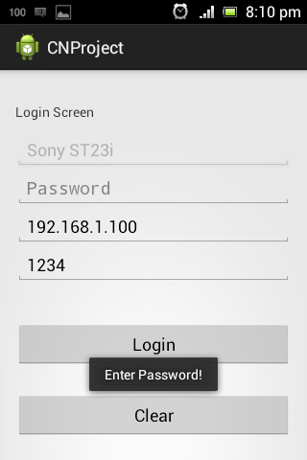**Login Error Checking:**

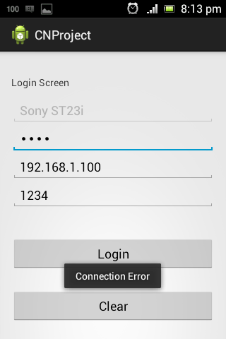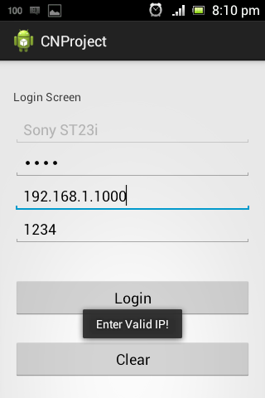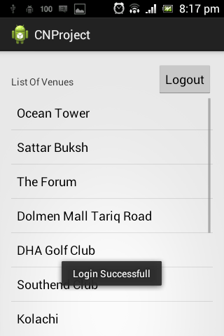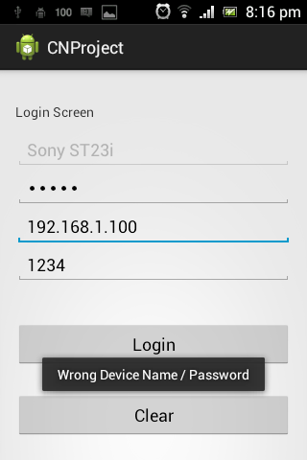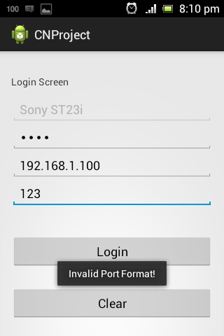

# Check In Error Checking :

